UNIVERSITY OF INFORMATION TECHNOLOGY & VIETNAM KOREA COMMUNICATION

**Faculty of Computer Science**



**REPORT**

**Base project 2**

**NAME OF PROJECT**

**BUILD AN ELECTRONICS SHOPPING WEBSITE**

**Student: Le Dinh Phuc – 22IT226**

**Truong Huynh My Tam - 21IT061**

**Class: 22GIT1**

**Instructors: Nguyen Thu Huong**

***Da Nang, month 12 year 2023***

Thank you

To create this website, our team received a lot of support and help from the instructor - Ms. Nguyen Thu Huong.

With deep and sincere feelings, allow me to express my gratitude to you and all of you who have helped and researched together throughout the process of implementing the topic. With limited time and experience, this report cannot avoid shortcomings. We look forward to receiving the teachers' guidance and architectural comments, from which we can supplement and improve our experience and better serve the following projects.

Our team would like to sincerely thank you!

*Student*

Le Dinh Phuc

Truong Huynh My Tam

INSTRUCTOR REVIEWS

**TABLE OF CONTENT**

Chapter 1: INTRODUCTION 1

1.1 Overview: 1

1.1.1 Name of project: 1

1.1.2 Introduction: 1

1.1.3 Objectives: 1

1.1.4 Logo website: 1

1.1.5 Implementation plan: 2

1.2 Methodology, results: 2

1.3 Project structure: 3

Chapter 2: SYSTEM ANALYSIS AND DESIGN 4

1.4 System requirement 4

1.5 System Usage: 5

1.5.1 List of Use Cases: 5

1.5.2 Use Case Specification: 6

1.5.3 Using Use Case Diagrams: 25

1.6 Class diagram: 27

1.6.1 List of classes: 27

1.7 Activity diagram: 29

1.7.1 General diagram: 29

1.7.2 Log in to the website: 30

1.7.3 Register an account: 31

1.7.4 Add product (Admin): 32

1.7.5 Product deletion (Administrator): 33

1.7.6 Buy products: 34

1.8 State diagram: 34

1.8.1 Login: 34

1.8.2 Register 35

1.8.3 Shopping cart management: 35

1.9 Interaction diagram (Sequence diagram): 36

1.9.1 General diagram: 36

1.9.2 Log in to the website: 37

1.9.3 Register an account: 37

1.9.4 Add product (Admin): 38

1.9.5 Delete a product (Admin): 38

1.9.6 Buy products: 39

1.9.7 Search product: 39

1.9.8 Search blog 40

1.9.9 Delete Blog (Admin) 40

1.10 Package diagram: 41

1.11 Component diagram: 42

1.12 Deployment diagram: 43

Chapter 3 DESIGNING WEBISITE INTERFACES 44

1.13 Analysis of Website Design Requirements: 44

1.13.1 Basic Requirements for an E-commerce Website: 44

1.13.2 Online Support: 44

1.13.3 Mobile Version: 44

1.13.4 SEO standard web design SEO-Friendly Design: 44

1.14 Expected Product Results: 44

1.15 Applied Technologies and Tools: 45

1.16 Results: 45

Chapter 4 CREATING DATABASES AND CONNECTIONS 49

1.17 Technologies and Tools Applied: 49

1.18 Achieved Results: 49

Chapter 5 CONCLUSION 50

1.19 Conclusion: 50

1.19.1 Advantages: 50

1.19.2 Limitations: 50

1.20 Development Directions: 50

REFERENCE DOCUMENTS 51

# Chapter 1: INTRODUCTION

## Overview:

### Name of project:

“Build an electronics shopping website”

### Introduction:

Nowadays, the demand for personal computers and laptops is continuously increasing due to the relentless development of computer technology and electronic networks. This has led to a significant growth in the electronic device market, especially for laptops, in recent times.

For office workers, computers serve as a means to quickly exchange information and work with superiors and leaders. Particularly for those organizations that do not provide personal laptops for their employees, owning a computer is essential and crucial. This facilitates smoother and more convenient work operations, enhancing efficiency.

Understanding the market situation and consumer needs, we have initiated this website to help address these demands and provide a platform for consumers to access essential computer equipment. Simultaneously, it demonstrates the ability to absorb and enhance the knowledge of Information Technology students at the University of Information Technology – Vietnam – Korea. .

### Objectives:

#### The objective of the project is to bring products, equipment, and components related to computers and laptops to the hands of consumers.

### Logo website:



### Implementation plan:

|  |  |
| --- | --- |
| **Time** | **Implementation content** |
| Week 1  19/9 - 25/9. | Define the concept.  Meet with the advisor and review the outline. |
| Week 2  26/9 - 2/10 | Completing and submitting a project outline.  Planning the implementation of the project. |
| Week 3,4  3/10 - 16/10 | Research on competitors, the most popular websites currently of interest.  Their strengths, weaknesses.  Website interface design. |
| Week 5, 6, 7, 8  17/10 - 13/11 | Building the database as well as connecting the interface to the database.  Completing the functions of the website and fixing errors. |
| Week 9,10  14/11 - 28/11 | Edit and refine the website, avoiding any unnecessary errors. |
| Week 11  29/11 - 5/12 | Complete the Word and PowerPoint documents.  Finish the project. |

## Methodology, results:

* *Methodology:* Employed CSS, HTML, JavaScript, Spring Boot, and several other programming languages to develop the website interface. Utilized MySQL as the database and Java for connecting the website to the database.
* *Results:* Successfully completed website with full functionality, clear interface, and user-friendly design.

## Project structure:

The main content of the thesis consists of 4 Chapter:

* *Chapter 1*: Introduction: Overview of the issue, introduction, objectives, the problems to be addressed, and the research methodology.
* *Chapter 2:* System Analysis and Design: Based on the specified requirements, create diagrams to represent the website system.
* *Chapter 3*: Research Content and Results: Utilizing the previously created diagrams to design the interface, finalize functions, and complete the website.
* *Chapter 4*: Conclusion and Future Development: Draw conclusions from the achieved results, identify areas that were not achieved, and propose directions for the future development of the topic.

# Chapter 2: SYSTEM ANALYSIS AND DESIGN

## System requirement

* User Management:
  + An E-commerce website needs to provide a smooth and flexible user registration process. This includes options for registering via social accounts or email while ensuring the security of personal information. The user account system should offer the ability to manage personal information, track orders and purchase history, as well as update payment information.
* Product and Category Management:
  + Product management should ensure ease of adding, editing, and deleting products. The product category system should support flexible categorization to create a clear website structure. This helps users easily search and browse through various product types.
* Shopping Cart and Checkout:
  + The shopping cart feature should be flexible and convenient, allowing users to easily add and remove products. A secure checkout process is crucial, supporting multiple payment methods and ensuring the protection of the buyer's payment information.
* Product Display and Search:
  + The website should display products attractively, with high-quality images, detailed descriptions, and pricing information. Robust search and filtering tools enable users to quickly and easily find desired products based on various criteria.
* Interaction and Feedback:
  + The system needs to support product reviews and comments to build trust among buyers. Sharing products and reviews on social media platforms is an effective way to increase interaction and attract new attention.
* Order Management and Delivery:
  + Administrators need a robust order management system to track order statuses and provide detailed delivery information. Integration with a delivery service provides real-time information on the location and status of orders.
* Security and Privacy:
  + Securing personal and payment information is paramount. Buyers should have control and choices regarding the sharing of their personal information.
* Statistics and Analysis:
  + The system should have the ability to collect and analyze data on sales, shopping behavior, and other metrics. Through this analysis, administrators can make informed decisions to optimize the shopping experience.
* Notifications and Customer Care:
  + Sending notifications via email and browser alerts about orders, promotions, and product updates is an effective way to keep buyers engaged. Customer support channels need to be optimized to quickly address queries and issues.
* Payment Integration and Ad Removal (Optional):
  + Integration of a payment gateway makes it easy for users to access special content or remove ads through payment options or premium accounts.
* User Interface Customization:
  + Users should have the ability to customize the website interface to create a personalized shopping experience based on their preferences and desires. This may include changes to colors, layouts, and other options to adjust their shopping experience.

## System Usage:

### List of Use Cases:

- **Log in to the system:** Customers log in to the website system to interact with it.

- **Log out of the system:** Customers log out of the website system to disengage from the system.

- **Add to cart:** Customers add products to their shopping cart.

**- Place an online order:** Customers make online purchases of products on the website.

**- Search for a product:** Customers and guests search for products of interest on the website.

- **Payment:** Customers can make payments for their purchased products through various methods such as Credit Card, Bank Account, or Cash on Delivery.

- **Product Information Entry**: Administrators input information for new products and update details for existing ones.

- **Online Product Consultation:** Customer Service representatives advise customers on products they are interested in and recommend products based on customer needs.

- **Order Statistics Check:** Administrators review confirmed orders and check the shipping status of each order.

- **List of Customers Who Have Made Purchases:** Display a list of customers who have bought products.

**- Modify and Add Product Information:** Administrators can modify product details, change prices, delete products that are out of stock, or are no longer available for sale.

### Use Case Specification:

#### Logging into the System:

* Use Case ID: UC-1.
* Use Case Name: Logging into the System.
* Description: The user logs into the website system to access its services.
* Actor: Customer.
* Priority: Must have.
* Trigger: The user wants to log into the website system.
* Preconditions:

+ User account has been created.

+ User's device is connected to the Internet at the time of login.

* Postconditions:

+ User successfully logs in.

+ The system records the successful login activity.

* Basic Flow:

+ User accesses the website.

+ User enters website credentials and selects the 'Login' command.

+ The system verifies the login information successfully and allows user access to the website.

+ The system records the successful login activity.

* Exception flow:

+ The login information authentication system fails to authenticate and displays an error message.

+ Users are unable to log in to the website system.

#### Account Registration:

* Use Case ID: UC-2.
* Use Case Name: Account Registration.
* Description: Users register to become members of the website.
* Actor: Customer.
* Priority: Must have.
* Trigger: The user wants to become a member of the website to avail discounts.
* Preconditions:

+ The user does not have an account on the website.

+ The user wants to purchase a product from the website.

+ The user's device is connected to the Internet at the time of registration.

* Basic Flow:

+ The user accesses the website.

+ The user selects the "Register" function.

+ The user enters information into the form and selects the "Register" command.

+ The system verifies the information and creates the account.

* Alternative Flow:

+ The user cancels the registration.

#### Adding to Cart

* Use Case ID: UC-3
* Use Case Name: Add to Cart. Description: Users add favorite or planned-to-purchase products to their shopping cart.
* Actors: Guest, Customer.
* Priority: Must-have.
* Trigger: The user wants to buy or plans to buy a product from the website.
* Preconditions:

+ The user has an account on the website.

+ The user is logged into the website system.

* Postconditions:

+ The selected product has been added to the user's shopping cart.

* Basic Flow:

+ The user accesses the website.

+ The user logs into the website.

+ The user selects a favorite or planned-to-purchase product.

+ The user clicks the "Add to Cart" button to add the product to the shopping cart.

* Alternative Flows:

+ The user is not logged into the website.

+ The user does not purchase any products.

#### Online Ordering:

* Use Case ID: UC-4.
* Use Case Name: Online Ordering.
* Description: Users place orders for products they wish to purchase on the website.
* Actors: Customer, Admin.
* Priority: Must have.
* Trigger: Users research the product they intend to buy.
* Preconditions:

+ Users log in to the website.

+ Users research the product they intend to buy.

+ User's device is connected to the Internet when placing the order.

* Postconditions:

+ An order is created and confirmed by the system.

+ System administrator processes the order.

* Basic Flow:

+ User accesses the website.

+ User logs in to the website.

+ User researches the product they intend to buy.

+ User adds the product to the shopping cart.

+ The system displays product information including Name, Price, Quantity.

+ User checks the shopping cart to ensure correct product and information.

+ The system displays the payment method for the order.

+ User selects the payment method and clicks the "Place Order" button to confirm the order.

+ The system creates and confirms the order.

* Alternative Flow:

+ User cancels the order.

#### Reset password

* Use Case Name: Reset Password
* Description: The user initiates the process to reset their password for accessing the website.
* Actor: User
* Priority: Must have
* Trigger: User selects the "Forgot Password" or similar option on the login page.
* Preconditions:
  + The user has an existing account on the website.
  + The user is not logged into the website system.
* Postconditions:
  + The user's password is successfully reset, and they receive confirmation.
* Basic Flow:
  + The user navigates to the login page and clicks on the "Forgot Password" link.
  + The system prompts the user to enter their email address associated with the account.
  + The user enters their email address and clicks on the "Submit" or "Reset Password" button.
  + The system validates the email address for correctness and existence in the database.
  + If the email address is valid, the system generates a unique token for password reset and sends a reset link to the user's email.
  + The user receives an email containing the reset link and clicks on it.
  + The system validates the reset token and prompts the user to enter a new password.
  + The user enters a new password and confirms it.
  + The system validates the new password for complexity and completeness.
  + If the new password meets the requirements, the system updates the user's password in the database.
  + The system displays a success message indicating that the password has been reset.
  + The user can now log in using the updated password.
* Exception Flow:
  + If the entered email address is not valid or does not exist in the system:
    - The system displays an error message indicating that the email address is not recognized.
    - The user is prompted to enter a valid email address or register for a new account.
  + If there is an issue generating or sending the reset email:
    - The system displays an error message indicating that the password reset email could not be sent.
    - The user is advised to check their email address or contact support for assistance.
  + If the reset token is invalid or expired:
    - The system displays an error message indicating that the reset link is no longer valid.
    - The user is prompted to initiate the password reset process again.
  + If the new password does not meet the specified requirements:
    - The system displays an error message indicating the password requirements.
    - The user is prompted to enter a new password that complies with the specified criteria.

#### Make payment

* Use Case Name: Make Payment
* Description: The user initiates the process to make a payment for the items in their shopping cart on the ecommerce website.
* Actor: User
* Priorities: Must have
* Trigger: User selects the "Checkout" or similar option after adding items to the shopping cart.
* Preconditions:
  + The user is logged into their account on the ecommerce website.
  + The user has items added to their shopping cart.
  + The user has selected the "Checkout" option.
* Postconditions:
  + The payment is successfully processed.
  + The order is confirmed, and the user receives an order confirmation.
  + The purchased items are removed from the user's shopping cart.
* Basic Flow:
  + The user navigates to the shopping cart or checkout page after adding desired items.
  + The system displays the list of items in the user's shopping cart.
  + The user confirms the items and selects the "Checkout" or "Proceed to Payment" button.
  + The system prompts the user to select a payment method (e.g., credit card, PayPal, etc.).
  + The user chooses their preferred payment method and enters the necessary payment details.
  + The system securely processes the payment through a payment gateway.
  + The payment gateway provides a response indicating the success or failure of the transaction.
  + If the payment is successful, the system generates an order confirmation.
  + The order confirmation includes details such as order number, items purchased, billing, and shipping information.
  + The system updates the user's order history with the new order.
  + The purchased items are removed from the user's shopping cart.
  + The user receives an email confirmation with the order details.
* Exception Flow:
  + If the user's payment information is invalid or incomplete:
    - The system displays an error message indicating the issue with the payment details.
    - The user is urged to correct the payment information and retry.
  + If the payment transaction fails:
    - The system displays an error message indicating the failure to process the payment.
    - The user is urged to choose a different payment method or contact support for assistance.
  + If the selected items are no longer available or the inventory has changed:
    - The system displays an error message indicating that the item availability has changed.
    - The user is prompted to review and modify their order accordingly.
  + If there is an issue with the order confirmation generation or email delivery:
    - The system displays an error message indicating the problem with order confirmation.
    - The user is advised to check their email or contact customer support for assistance.
  + If the user abandons the payment process:
    - The system retains the items in the shopping cart for future reference.
    - The user can return later to complete the payment process.

#### Rating

* Use Case Name: Rating
* Description: The user provides a rating and optional review for a purchased product on the e-commerce website.
* Actor: User
* Priorities: Important
* Trigger: User selects the option to rate and review a purchased product.
* Preconditions:
  + The user is logged into their account on the e-commerce website.
  + The user has completed a purchase for the product they want to rate.
* Postconditions:
  + The user's rating and optional review are successfully submitted.
  + The product's overall rating is updated.
  + The user's feedback is visible on the product's page.
* Basic Flow:
  + The user navigates to the product page of the purchased item.
  + The system displays information about the product, including existing ratings and reviews if any.
  + The user selects the options to provide a rating and review.
  + The system presents a user interface with a rating scale (e.g., 1 to 5 stars) and a text area for entering a review.
  + The user chooses a rating on the scale, where a higher value represents a more positive rating.
  + Optionally, the user enters a review in the provided text area.
  + The user clicks on the "Submit" or "Post" button to submit their rating and review.
  + The system validates the entered information for any errors or missing data.
  + If there are no errors, the system associates the rating and review with the purchased product.
  + The system updates the overall rating for the product based on the new submission.
  + The user's feedback is displayed along with existing ratings and reviews on the product page.
  + The user receives a confirmation message indicating that their rating and review have been successfully submitted.
* Exception Flow:
  + If the user tries to provide a rating without being logged in:
    - The system displays an error message indicating that the user needs to log in to rate the product.
    - The user is redirected to the login page.
  + If the user tries to rate a product they haven't purchased:
    - The system displays an error message indicating that the user cannot rate a product they haven't purchased.
    - The user is advised to review products they have purchased.
  + If there is an error during the submission process:
    - The system displays an error message indicating that the rating and review could not be submitted.
    - The user can retry the rating process or contact support for assistance.
  + If the user provides a rating but doesn't enter a review (optional):
    - The system accepts the rating without a review and funds with the submission.
    - The user receives a confirmation message indicating that their rating has been submitted.

#### Search product

* Use Case Name: Search Product
* Description: The user initiates a search for a specific product or category on the e-commerce website.
* Actor: User
* Priorities: Important
* Trigger: User enters a search query in the website's search bar or selects the search option.
* Preconditions:
  + The user is on the e-commerce website.
  + The website has products available for purchase.
* Postconditions:
  + The search results matching the user's query are displayed.
  + The user can view detailed information about the products in the search results.
* Basic Flow:
  + The user enters a search query in the website's search bar.
  + The system processes the search query and retrieves relevant products matching the query.
  + The system displays a list of search results with product names, images, and brief descriptions.
  + The user can scroll through the search results to find the desired product.
  + The user clicks on a specific product from the search results to view detailed information.
  + The system navigates the user to the product page, showing additional details such as price, specifications, and customer reviews.
  + Optionally, the user can add the product to their shopping cart or proceed with the purchase.
  + The user can refine or modify their search query and repeat the process if necessary.
* Exception Flow:
  + If there are no search results for the entered query:
    - The system displays a message indicating that no products match the search criteria.
    - The user is encouraged to refine their search query or explore other products on the website.
  + If the search query is too broad and returns a large number of results:
    - The system may provide filtering options to help the user narrow down their search.
    - The user can apply filters such as price range, brand, or category to refine the results.
  + If there is an issue with the search functionality:
    - The system displays an error message indicating that the search feature is temporarily unavailable.
    - The user is advised to try again later or contact support for assistance.
  + If the user's internet connection is lost during the search:
    - The system displays an error message indicating the loss of connection.
    - The user is prompted to check their internet connection and retry the search.

#### Receive notification

* Use Case Name: Notification receive
* Description: The user receives notifications about order updates, promotions, or relevant information on the e-commerce website.
* Actor: User
* Priorities: Important
* Trigger: The system generates notifications based on user-related events (e.g., order confirmation, promotions, account activities).
* Preconditions:
  + The user is registered and logged into their account on the e-commerce website.
  + The user has enabled notification preferences in their account settings.
* Postconditions:
  + The user receives notifications in a timely manner based on their selected preferences.
  + The notifications provide relevant and accurate information.
* Basic Flow:
  + The system identifies events that trigger notifications, such as order updates, promotions, or account activities.
  + The system checks the user's notification preferences to determine the preferred communication channels (e.g., email, SMS, in-app notifications).
  + The system generates a notification for the identified event.
  + The user, depending on their preferences, receives the notification through the chosen communication channel.
  + The notification contains relevant information about the event, such as order confirmation, shipping updates, or promotional offers.
  + The user views the notification on their preferred device or platform.
  + Optionally, the user takes appropriate actions based on the notification content (e.g., track an order, view details of a promotion).
  + The user can customize their notification preferences in the account settings.
* Exception Flow:
  + If the user has disabled notification preferences:
    - The system respects the user's preferences and does not send notifications.
    - The user is informed that notifications are disabled and can enable them in their account settings.
  + If there is an issue with the notification delivery system:
    - The system displays an error message indicating that notifications could not be delivered.
    - The user is advised to check their notification settings and ensure their chosen communication channels are functional.
  + If the notification contains sensitive information (e.g., account changes, password reset):
    - The system ensures that sensitive information is communicated securely.
    - The user may be urged to confirm their identity through a secure channel before receiving certain types of notifications.
  + If the user experiences issues with notification preferences not being saved:
    - The system displays an error message indicating that the preferences could not be updated.
    - The user is advised to check their internet connection or contact support for assistance.

#### Account management

* Use Case Name: Account Management
* Description: The administrator manages user accounts on the e-commerce website, performing actions such as account creation, modification, and deactivation
* Actor: Admin
* Priorities: Administrator
* Trigger: Administrator logs into the admin panel or accesses account functional managementities.
* Preconditions:
  + The administrator has valid credentials to access the admin panel.
  + The e-commerce website is operational.
* Postconditions:
  + User account information is accurately updated in the system.
  + Changes made by the administrator are reflected in the user's account status.
* Basic Flow:
  + The administrator logs into the admin panel using valid credentials.
  + The system authenticates the administrator and grants access to account management functionalities.
  + The administrator navigates to the account management section.
  + The system displays a list of user accounts, including relevant details such as username, email, and account status.
  + The administrator selects a specific user account for management.
  + The administrator can perform various actions, such as:
    - Creating a new user account:
      * The system prompts the administrator to enter necessary user information (e.g., username, email, password).
      * The system validates the entered information.
      * If valid, the new user account is created, and the administrator receives a confirmation.
    - Modifying user account details:
      * The system allows the administrator to update user information, such as email, password, or account status.
      * The administrator makes the necessary changes and saves them.
      * The system updates the user account information accordingly.
    - Deactivating a user account:
      * The administrator selects the option to deactivate a user account.
      * The system prompts for confirmation and displays potential consequences.
      * If confirmed, the user account is deactivated, and the system updates the account status.
  + The administrator may review and confirm the changes before finalizing.
  + The system updates the user account information in the database.
  + The administrator receives a confirmation message indicating the success of the account management action.
* Exception Flow:
  + If the administrator enters invalid credentials during login:
    - The system displays an error message indicating incorrect login credentials.
    - The administrator is urged to re-enter the correct credentials.
  + If there is an issue with the account creation process:
    - The system displays an error message indicating that the new account could not be created.
    - The administrator is advised to check the entered information and retry.
  + If there are issues updating or modifying user account details:
    - The system displays an error message indicating that the changes could not be saved.
    - The administrator is urged to review the modifications and retry or contact support for assistance.
  + If the administrator tries to deactivate a non-existent user account:
    - The system displays an error message indicating that the user account does not exist.
    - The administrator is advised to verify the user account before attempting deactivation.
  + If the administrator attempts to deactivate their own account:
    - The system prevents the deactivation of the administrator's account to ensure continued access to the admin panel.
    - The administrator is informed that self-deactivation is not allowed.
  + If there are security concerns related to account management actions:
    - The system may implement additional security measures, such as multi-factor authentication or logging of admin activities, to ensure secure account management.

#### Manage Users (Admin)

* Use Case Name: Manage Users
* Description: The administrator manages user accounts on the e-commerce website, performing actions such as viewing, modifying, and deactivating user accounts
* Actor: Admin
* Priorities: Must have
* Trigger: Administrator logs into the admin panel or accesses user functional management functions
* Preconditions:
  + The administrator has valid credentials to access the admin panel.
  + The e-commerce website is operational.
* Postconditions:
  + User account information is accurately updated in the system.
  + Changes made by the administrator are reflected in the user's account status.
* Basic Flow:
  + The administrator logs into the admin panel using valid credentials.
  + The system authenticates the administrator and grants access to user management functionalities.
  + The administrator navigates to the user management section.
  + The system displays a list of user accounts, including relevant details such as username, email, and account status.
  + The administrator can perform various actions, such as:
    - Viewing user details:
      * The system allows the administrator to view detailed information about a specific user by selecting the user's account.
      * The administrator can see user-specific details such as order history, preferences, and contact information.
    - Modifying user account details:
      * The system allows the administrator to update user information, such as email, password, or account status.
      * The administrator makes the necessary changes and saves them.
      * The system updates the user account information accordingly.
    - Deactivating a user account:
      * The administrator selects the option to deactivate a user account.
      * The system prompts for confirmation and displays potential consequences.
      * If confirmed, the user account is deactivated, and the system updates the account status.
  + The administrator may review and confirm the changes before finalizing.
  + The system updates the user account information in the database.
  + The administrator receives a confirmation message indicating the success of the user management action.
* Exception Flow:
  + If the administrator enters invalid credentials during login:
    - The system displays an error message indicating incorrect login credentials.
    - The administrator is urged to re-enter the correct credentials.
  + If there is an issue with the account modification process:
    - The system displays an error message indicating that the changes could not be saved.
    - The administrator is advised to check the entered information and retry or contact support for assistance.
  + If the administrator tries to deactivate a non-existent user account:
    - The system displays an error message indicating that the user account does not exist.
    - The administrator is advised to verify the user account before attempting deactivation.
  + If the administrator attempts to deactivate their own account:
    - The system prevents the deactivation of the administrator's account to ensure continued access to the admin panel.
    - The administrator is informed that self-deactivation is not allowed.
  + If there are security concerns related to user management actions:
    - The system may implement additional security measures, such as multi-factor authentication or logging of admin activities, to ensure secure user management.

#### Manage blog (Admin)

* Use Case Name: Manage blog
* Description: The administrator manages blog content on the e-commerce website, performing actions such as creating, editing, and deleting blog posts.
* Actor: Admin
* Priorities: Important
* Trigger: Administrator logs into the admin panel or accesses blog functionalities
* Preconditions:
  + The administrator has valid credentials to access the admin panel.
  + The e-commerce website has a blog feature enabled.
* Postconditions:
  + Blog content is accurately updated in the system.
  + Changes made by the administrator are reflected in the blog section of the website.
* Basic Flow:
  + The administrator logs into the admin panel using valid credentials.
  + The system authenticates the administrator and grants access to blog management functionalities.
  + The administrator navigates to the blog management section.
  + The system displays a list of existing blog posts, including relevant details such as title, date, and status.
  + The administrator can perform various actions, such as:
    - Creating a new blog post:
      * The system allows the administrator to create a new blog post by selecting the "Create New" option.
      * The administrator enters the blog post details, including title, content, and any relevant metadata.
      * The system validates the entered information.
      * If valid, the new blog post is created, and the administrator receives a confirmation.
    - Editing an existing blog post:
      * The system allows the administrator to edit the content, title, or other details of an existing blog post.
      * The administrator makes the necessary changes and saves them.
      * The system updates the blog post information accordingly.
    - Deleting a blog post:
      * The administrator selects the option to delete a blog post.
      * The system prompts for confirmation and displays potential consequences.
      * If confirmed, the blog post is deleted, and the system updates the blog section.
  + The administrator may review and confirm the changes before finalizing.
  + The system updates the blog post information in the database.
  + The administrator receives a confirmation message indicating the success of the blog management action
* Exception Flow:
  + If the administrator enters invalid credentials during login:
    - The system displays an error message indicating incorrect login credentials.
    - The administrator is urged to re-enter the correct credentials.
  + If there is an issue with the blog creation or modification process:
    - The system displays an error message indicating that the changes could not be saved.
    - The administrator is advised to check the entered information and retry or contact support for assistance.
  + If the administrator tries to delete a non-existent blog post:
    - The system displays an error message indicating that the blog post does not exist.
    - The administrator is advised to verify the blog post before attempting deletion.
  + If there are security concerns related to blog management actions:
    - The system may implement access controls to ensure that only authorized administrators can create, edit, or delete blog posts.
    - The system may log blog management activities for security and audit purposes.

#### Manage product

* Use Case Name: Manage products
* Description: The administrator manages product information on the e-commerce website, performing actions such as adding new products, updating existing product details, and removing products from the catalog
* Actor: Admin
* Priorities: Must have
* Trigger: Administrator logs into the admin panel or accesses product functional managementities
* Preconditions:
  + The administrator has valid credentials to access the admin panel.
  + The e-commerce website is operational.
* Postconditions:
  + Product information is accurately updated in the system.
  + Changes made by the administrator are reflected in the product catalog of the website
* Basic Flow:
  + The administrator logs into the admin panel using valid credentials.
  + The system authenticates the administrator and grants access to product management functionalities.
  + The administrator navigates to the product management section.
  + The system displays a list of existing products, including relevant details such as name, price, and availability.
  + The administrator can perform various actions, such as:
    - Adding a new product:
      * The system allows the administrator to create a new product by selecting the "Add New Product" option.
      * The administrator enters the product details, including name, description, price, and inventory information.
      * The system validates the entered information.
      * If valid, the new product is added to the catalog, and the administrator receives a confirmation.
    - Updating existing product details:
      * The system allows the administrator to edit the details of an existing product, such as name, description, price, or inventory.
      * The administrator makes the necessary changes and saves them.
      * The system updates the product information accordingly.
    - Removing a product from the catalog:
      * The administrator selects the option to remove a product.
      * The system prompts for confirmation and displays potential consequences.
      * If confirmed, the product is removed from the catalog, and the system updates the product list.
  + The administrator may review and confirm the changes before finalizing.
  + The system updates the product information in the database.
  + The administrator receives a confirmation message indicating the success of the product management action
* Exception Flow:
  + If the administrator enters invalid credentials during login:
    - The system displays an error message indicating incorrect login credentials.
    - The administrator is urged to re-enter the correct credentials.
  + If there is an issue with the product creation or modification process:
    - The system displays an error message indicating that the changes could not be saved.
    - The administrator is advised to check the entered information and retry or contact support for assistance.
  + If the administrator tries to remove a non-existent product:
    - The system displays an error message indicating that the product does not exist.
    - The administrator is advised to verify the product before attempting removal.
  + If there are security concerns related to product management actions:
    - The system may implement access controls to ensure that only authorized administrators can add, edit, or remove products.
    - The system may log product management activities for security and audit purposes.

### Using Use Case Diagrams:

#### General Diagram:

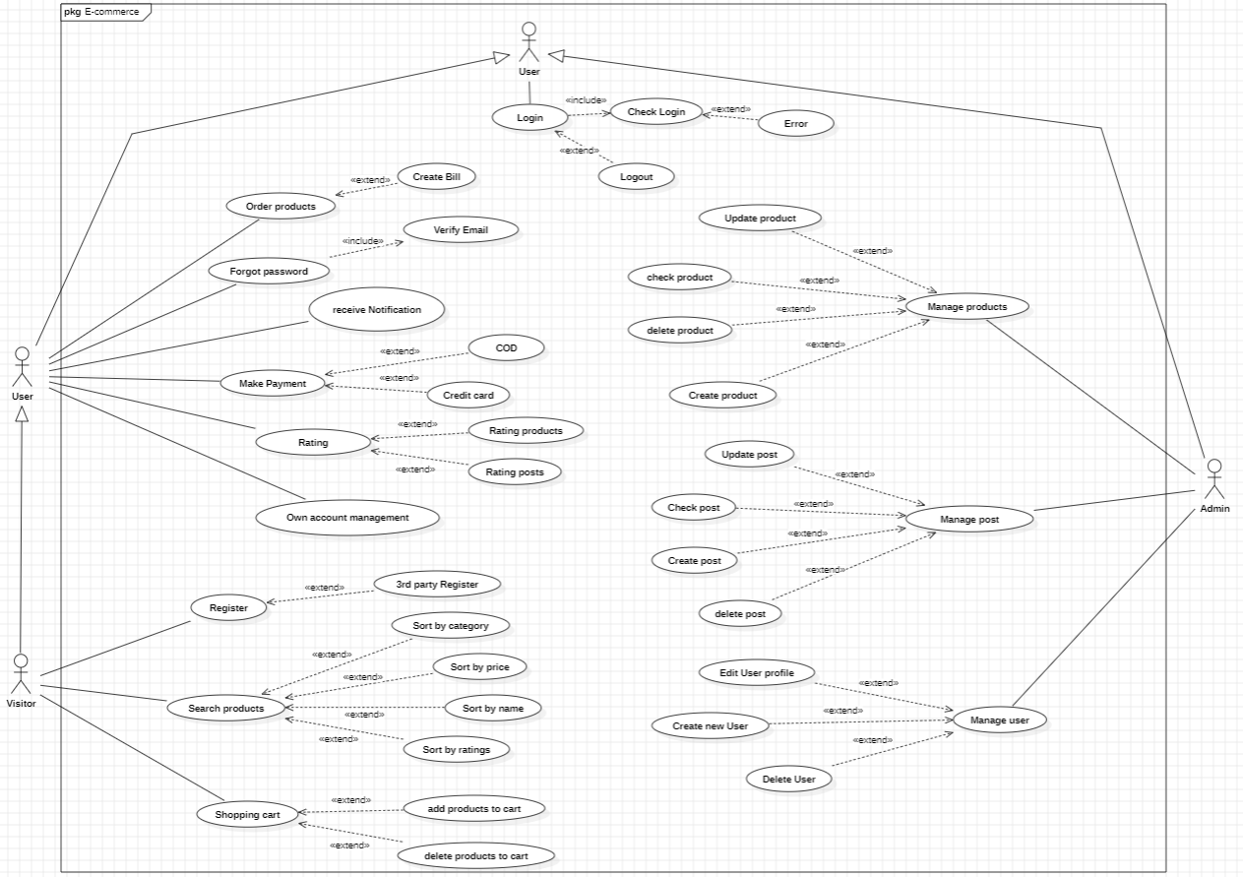

*P 1. General diagram*

#### Log in:

# 

*P 2. Use case - Login*

#### Sign up:

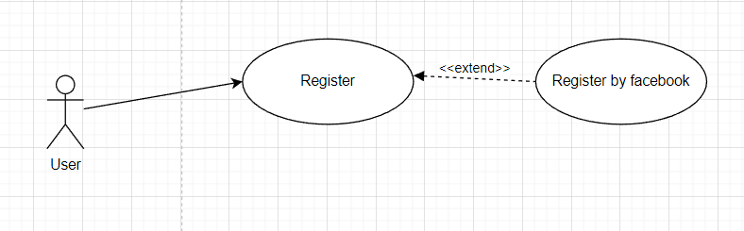

*P 3. Use case case - Register*

#### Adding to cart:

*P 4. Use case - Add to cart*

#### Online ordering:

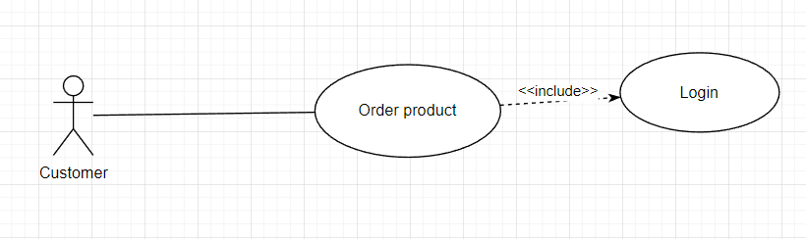

*P 5. Use case- Order*

## Class diagram:

### List of classes:

* Product.
* Product category.
* Brand.
* Order.
* Coupon.
* User
* Blog.
* Blog category

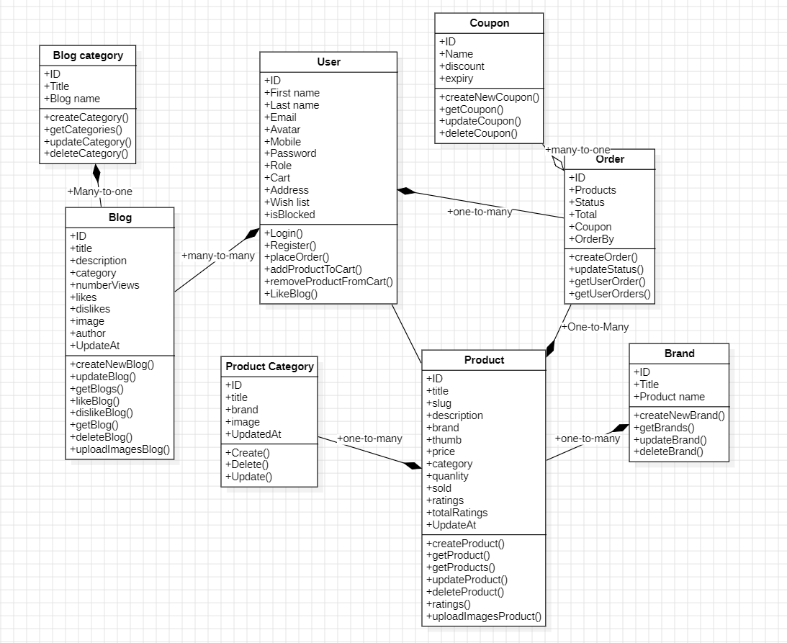  
  
*P 6. Class diagram*

## Activity diagram:

### General diagram:

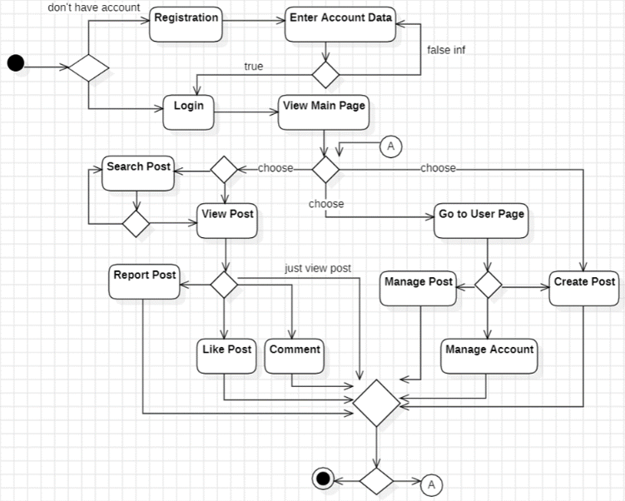

*P 7. Blog management activity diagram*

### Log in to the website:

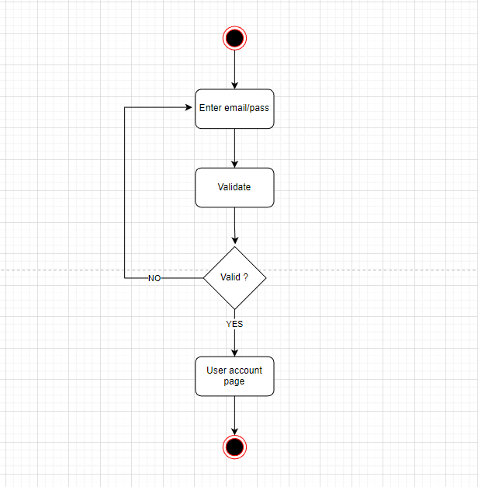

*P 8. Activity diagram - Login*

### Register an account:

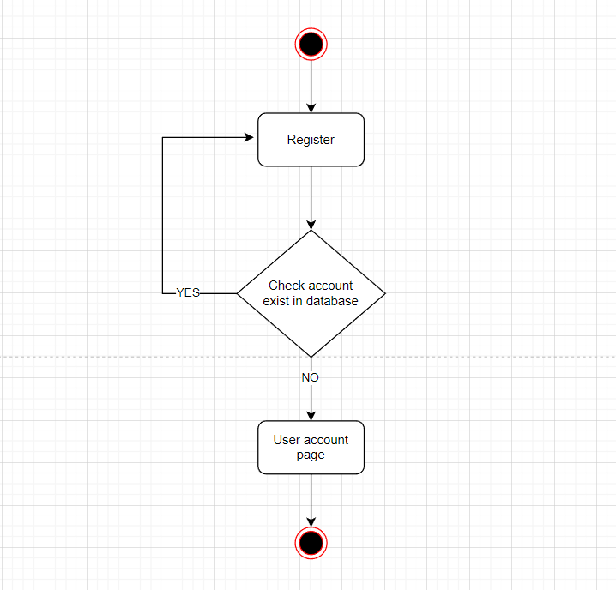

*P 9. Activity diagram - Register an account*

### Add product (Admin):

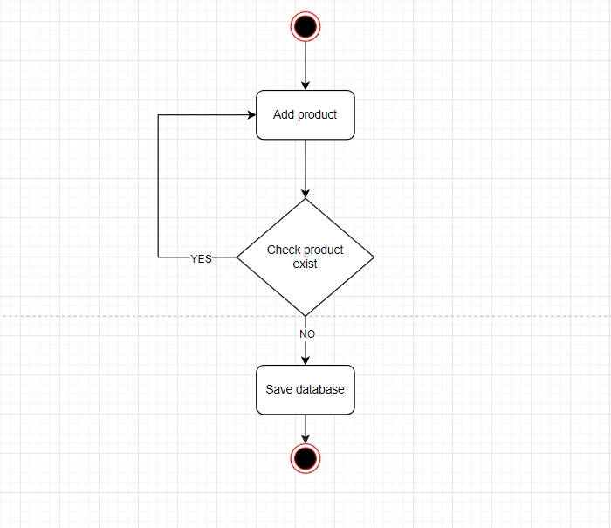

*P 10. Activity diagram - Add product*

### Product deletion (Administrator):

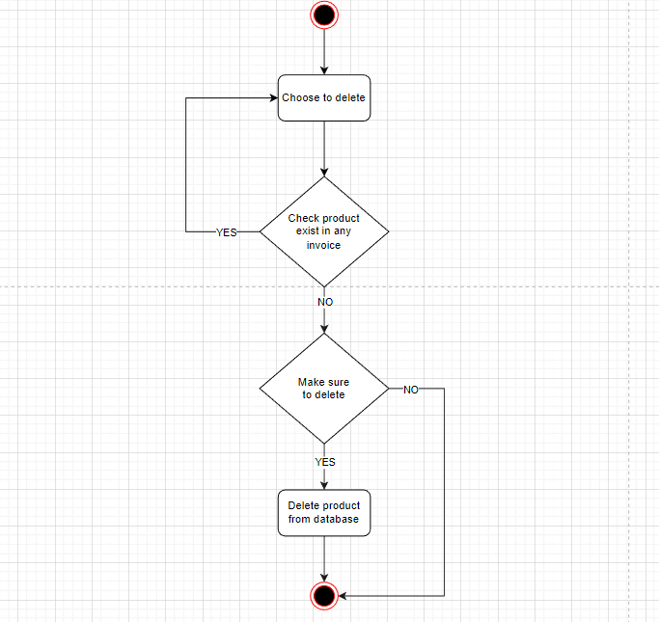

*P 11. Activity diagram - Delete product*

### Buy products:

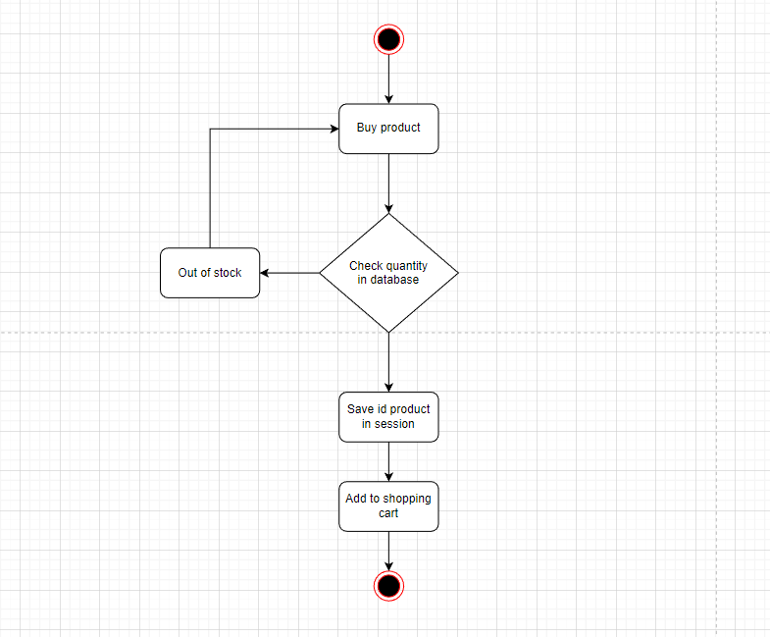

*P 12. Activity diagram - Buy products*

## State diagram:

### Login:

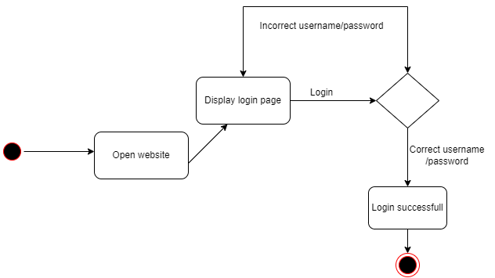

*P 13. State Diagram - Login*

### Register

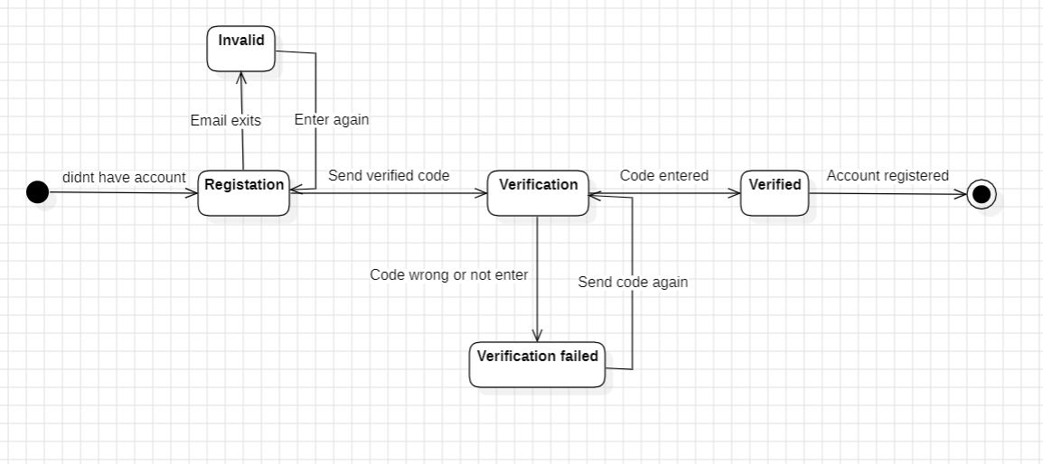

*P 13.5. State diagram – Registration*

### Shopping cart management:

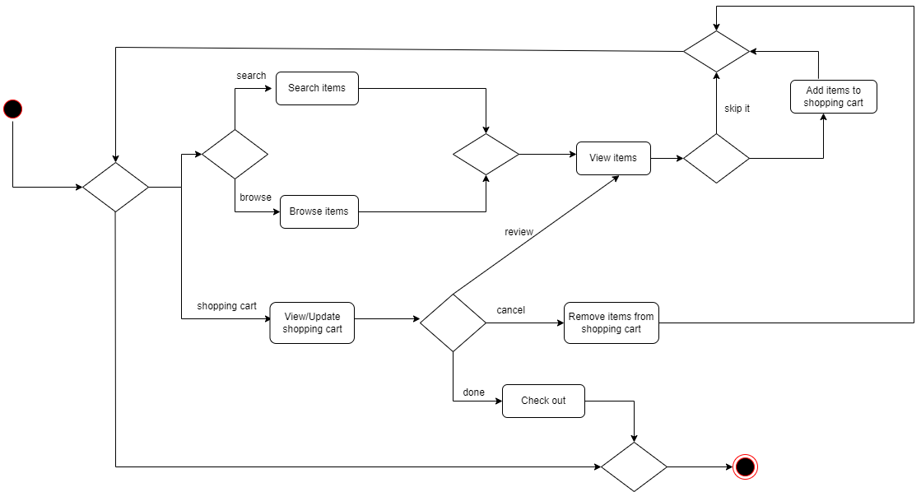  
  
  
  
  
*P 14. State diagram - Cart management*

## Interaction diagram (Sequence diagram):

### General diagram:

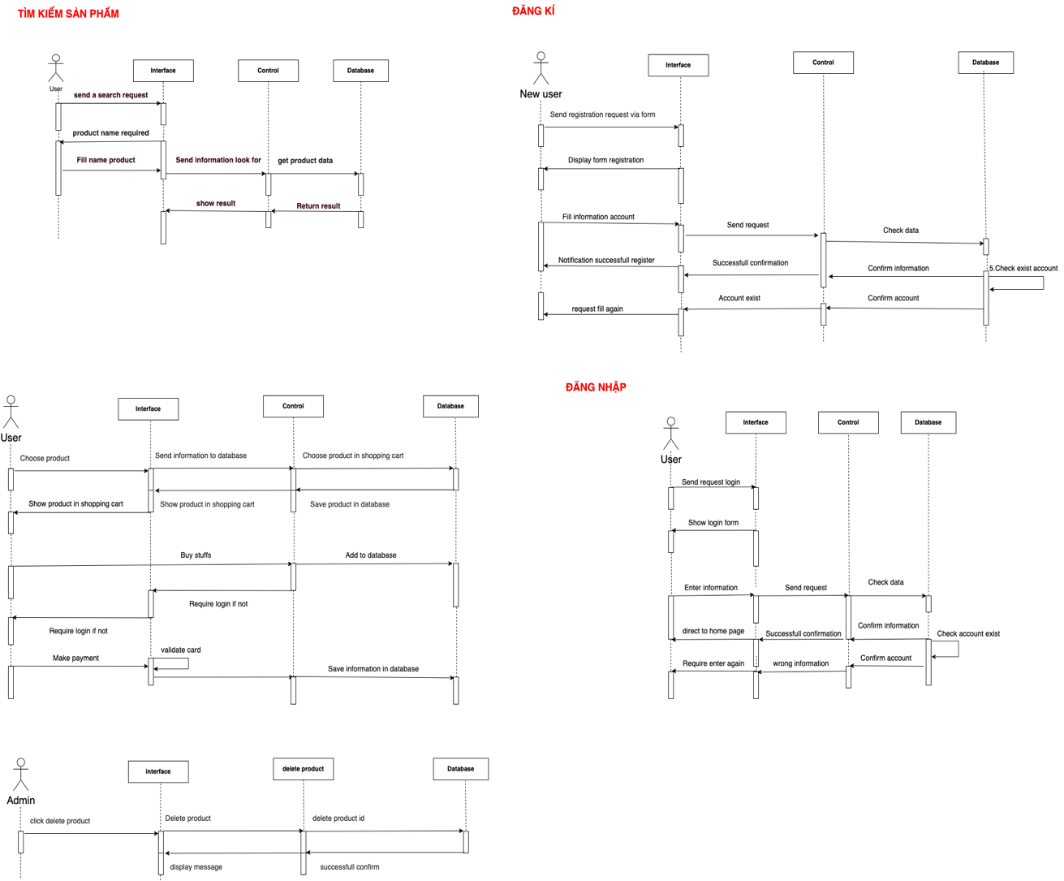

*P 15. Sequence diagram- General diagram*

### Log in to the website:

# 

*P 16. Sequence diagram - Login*

### Register an account:

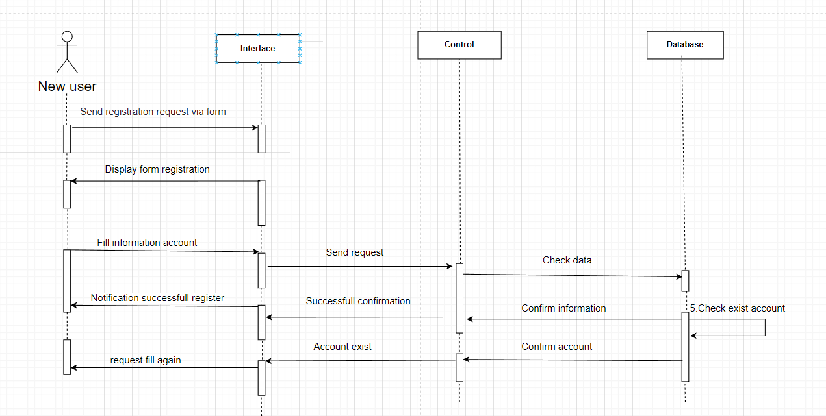

*P 17. Sequence diagram - Register an account*

### Add product (Admin):

*P 18. Sequence diagram - Add product*

### Delete a product (Admin):

*P 19. Sequence diagram -Delete product*

### Buy products:

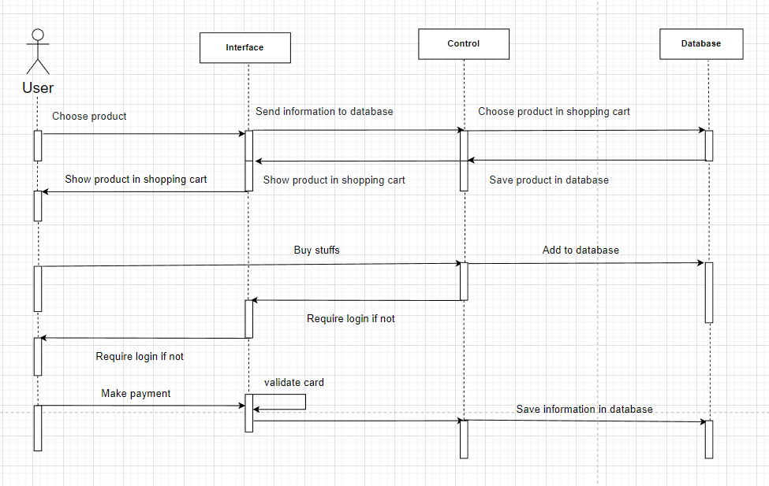

*P 20. Sequence diagram - Buy product*

### Search product:

*P 21. Product search sequence diagram*

### Search blog

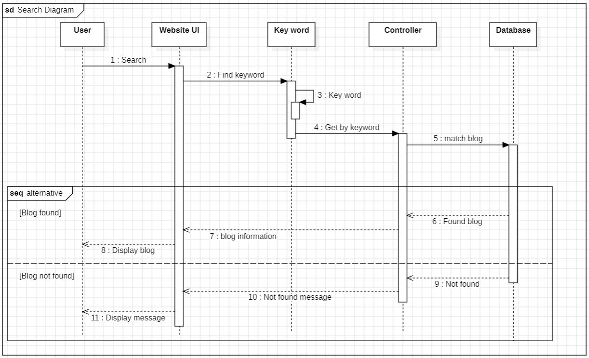

*P 22. Search blog*

### Delete Blog (Admin)

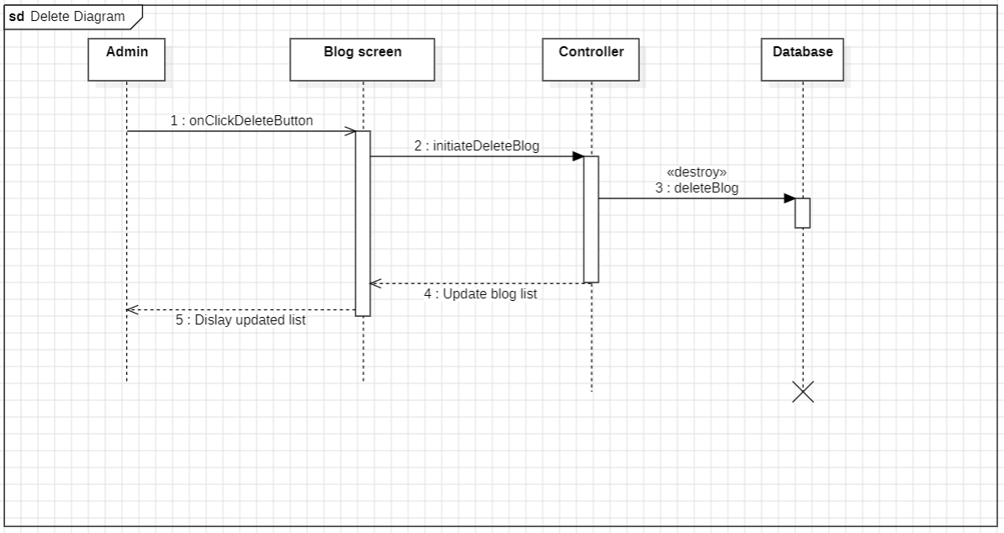

*P 23. Delete blog*

## Package diagram:

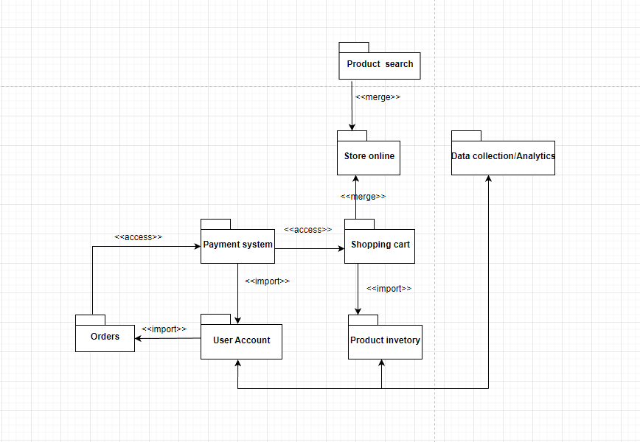

*P 24. General package diagram*

## Component diagram:

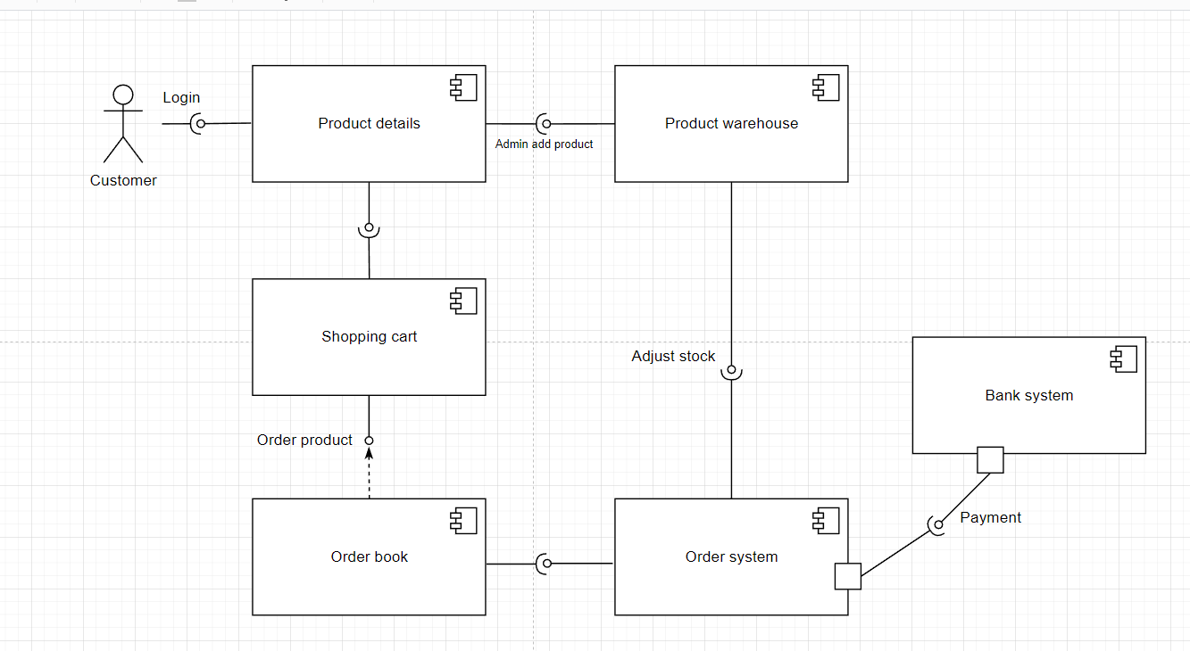

*P 25. General component diagram*

## Deployment diagram:

# 

*P 26. General deployment diagram*

# Chapter 3 DESIGNING WEBISITE INTERFACES

## Analysis of Website Design Requirements:

### Basic Requirements for an E-commerce Website:

- User-friendly interface: For an e-commerce website, having a user-friendly interface is a crucial requirement. It facilitates easy access for first-time users. An aesthetically pleasing website is also equally important. It helps to create attention, allure, and appeal to users from their initial visit. Making a positive impression on users during their first visit is essential for the growing success of the website.

### Online Support:

- **Designing an e-commerce website with comprehensive online consultation functionality brings satisfaction to users and enhances the website's credibility and trust. Providing excellent customer service becomes easier with such features. Not all customers want to read or view images; some may have other issues that require assistance. If online support tools such as integrated Zalo, Messenger, Tawk.to, etc., are not installed on your website, users seeking assistance might easily abandon the site**.

### Mobile Version:

-A website with mobile compatibility provides quick and efficient access for all users. Active access through various devices allows users to avail services and seek advice from anywhere at any time. This further enhances the website's reputation and creates a professional impression for users.

### SEO standard web design SEO-Friendly Design:

- SEO standards for a website are extremely important as they directly impact the ability to reach a specific number of customers. When Vietnamese users trust Google significantly, a website with SEO-friendly design and high search engine rankings gains substantial trust. Therefore, when designing a website for specialties or culinary purposes, paying attention to SEO standards is an indispensable requirement that should never be overlooked.

## Expected Product Results:

The website interface is designed to serve two main user groups: customers looking to purchase computer devices, components, and administrators (admins) responsible for managing product information, orders, as well as account management.

Anticipated pages include:

* Users:
  + Log in to the website, register as a member.
  + View information about products available on the website.
  + Shopping cart, enter delivery information.
* Administrators:
  + Log in to the website.
  + View, update, delete, edit information about products, orders, accounts.
  + Personal information can be modified.
  + Manage user information but without the authority to modify that information.

## Applied Technologies and Tools:

##### Use Visual Studio Code as a text editor for code.

##### Use Reactjs, Tailwind library for layout, formatting of the web interface.

* + Use JavaScript programming language, Jquery library, Ajax for building basic functions of the website.

## Results:

* **Home page:**

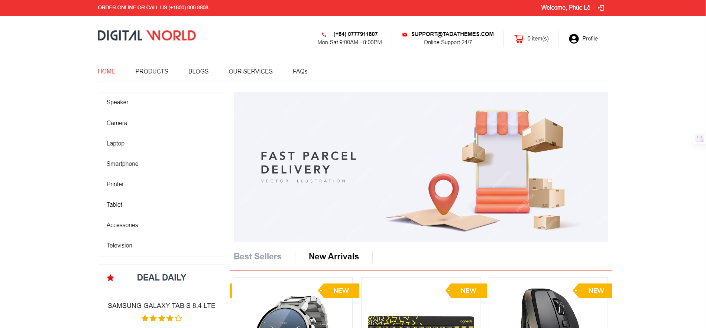

*P 22. Home page*

* Login page

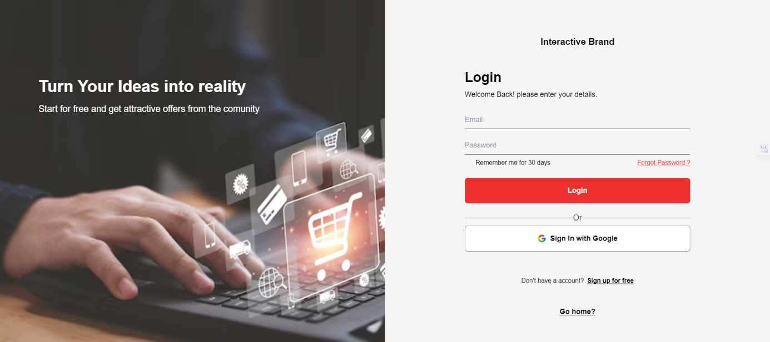

*P 23. Login page*

* Account registration page.

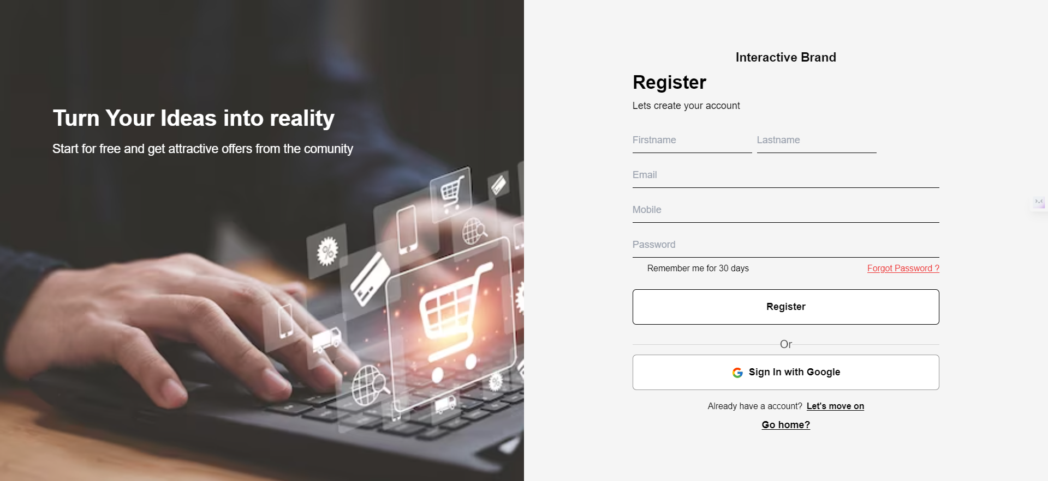

*P 24. Register an account*

* View the list of products on the website

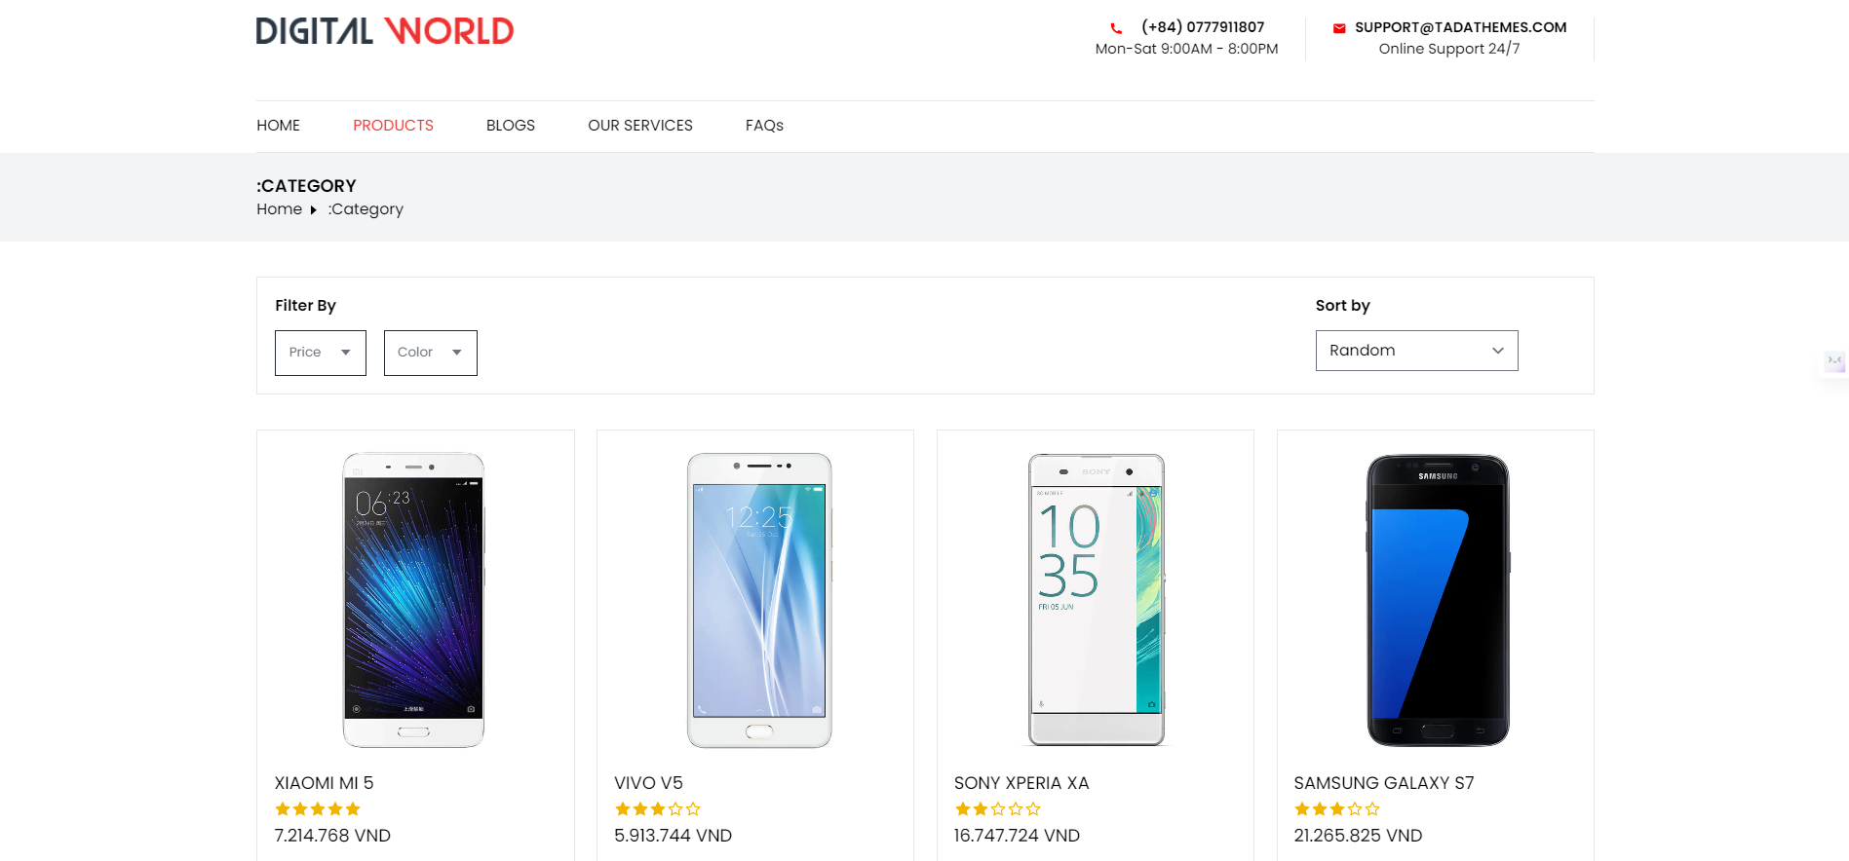

*P 25: Product portfolio*

* Product detail information page

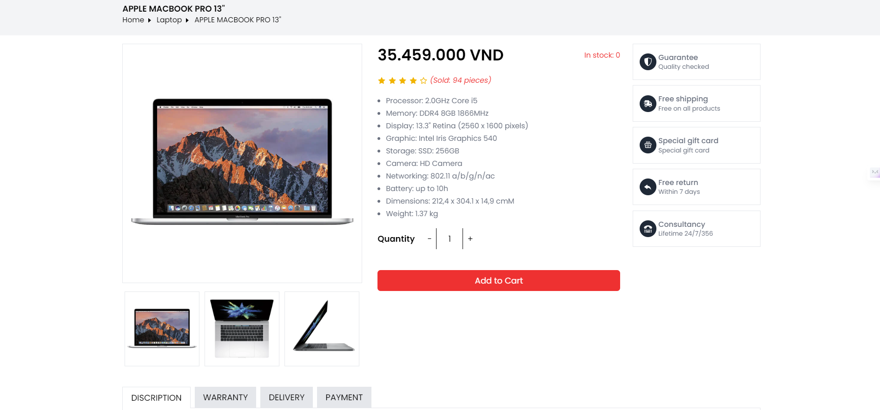

*P 26. Product detail information page*

* Admin page

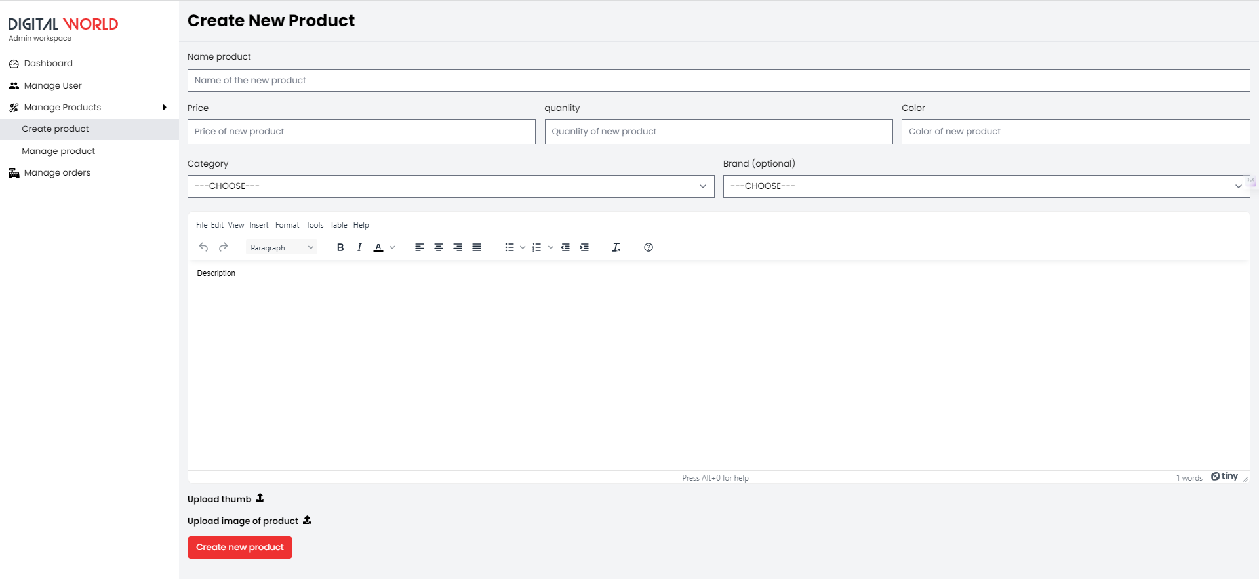

*P 27. Admin page*

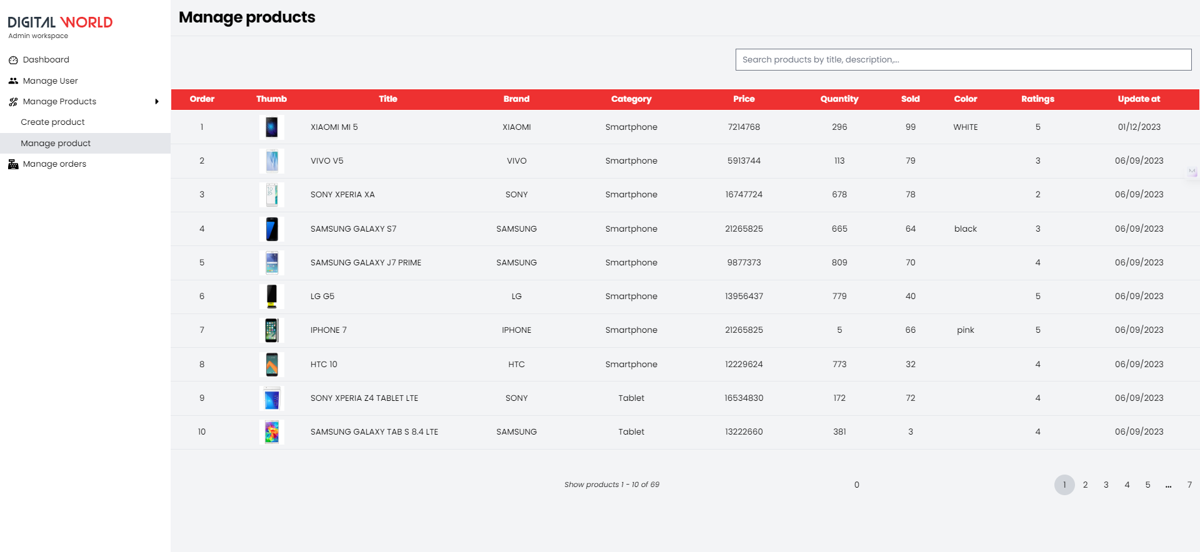

*P 31. Admin page*

# Chapter 4 CREATING DATABASES AND CONNECTIONS

## Technologies and Tools Applied:

- Using MongoDB Compass for code editing.

- Employing NoSQL to build the database.

- Utilizing Node.js to develop a server for connecting to the database and processing data.

## Achieved Results:

- Successfully constructing the database and establishing a successful connection between the database and the website.

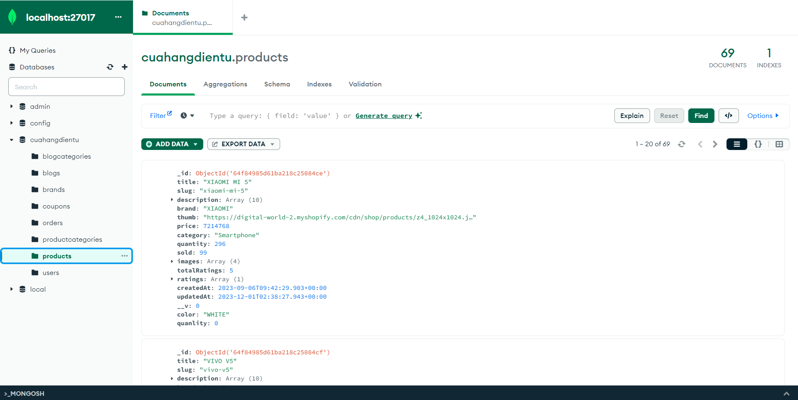

*P 32. Minh họa cơ sở dữ liệu*

# Chapter 5 CONCLUSION

## Conclusion:

### Advantages:

* Explored Node.js and React.js, expanding personal foundational knowledge.
* Utilized acquired knowledge of Node.js to develop the server, connect to the database and process data.
* Simple, tidy, and bright user interface.
* Designed a logical layout for the website, implementing basic features of an online shopping site.
* Comprehensive information on displayed products.
* Team members actively contributed to the website's interface, successfully completed assigned tasks.

### Limitations:

* + The website is still small and somewhat simulation-oriented.
  + Some areas are not well-executed.
  + Limited information available.
  + No mobile application support designed.
  + Contact feature is not fully developed.
  + No pre-payment options available; only Cash on Delivery (COD) is supported.

## Development Directions:

* + Build a website that meets all system business requirements.
  + Develop additional payment features using credit cards, e-wallets, and establish connections with banks.
  + Integrate with all devices and operating systems.
  + Complete all functions for the website.

# REFERENCE DOCUMENTS

[1] Article: Mr. Nguyen Thai Binh: " Increased Demand for Laptops During the Pandemic SeaSon ": <https://baobinhdinh.vn/viewer.aspx?macm=39&macmp=39&mabb=220530>

[2] Article: Mr. Nguyen Thanh Binh: " Analysics and design system "